The Major Scale – Key of C
The C Major Scale is the first and most important scale in music theory. It contains 7 notes and none of them are # (sharps) or b (flats). Therefore, the progression of notes goes logically from C as follows:
C D E F G A B (C)
The notes are also assigned numbers which relate to their position in the scale in relation to the 1st and root note (C), which in musical terms is known as the interval. Different combinations of intervals of a scale played together are what is known as harmony. This will be useful when discussing the harmonisation of the major scale; ie. Learning how chords are created.
C D E F G A B (C)
I II III IV V VI VII I (I) is also known as the Root
Now, to make this combination of notes there is a specific formula. The guitar neck is divided by frets. The distance between neighbouring frets is a half step or a semitone. The distance between one root note and the root note an octave above it is 12 frets, which is 12 half steps or 12 semitones. Since we are looking at the Key of C, count the frets from C on the 3rd fret/5th string up to C on the 15th fret/5th string
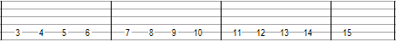
This is also known as the Chromatic Scale. To move chromatically basically means half step by half step/fret by fret. As previously mentioned, the Major Scale only has 7 notes in it and what we have here is 12 notes (not including the repeated root note at the 15th fret). The 12 notes are:
C, C#, D, D#, E, F, F#, G, G#, A, A#, B, (C)
# and b notes are interchangeable and depending on what key you are in you may see either symbol. For example C# is the same note as Db. A# is the same note as Bb…. See the previous chromatic scale below but with both # and b shown:
C, C#/Db, D, D#/Eb, E, F, F#/Gb, G, G#/Ab, A, A#/Bb, B, C
Since the C Major Scale conveniently has no # or b, you can remove them from the chromatic scale above to be left with C Major again
C D E F G A B C
Let’s look at this scale on a fret board:
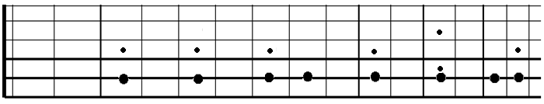
The distances between the notes in this scale are definitely worth looking closely at. From: C to D are 2 half steps
D to E are 2 half steps
E to F is 1 half step
F to G is 2 half steps
G to A is 2 half steps
A to B is 2 half steps
B to C is 1 half step
This can be written now as a formula: 2 2 1 2 2 2 1 – The Major Scale formula.
This formula can be applied to other keys. Let’s look at the key of E and construct the E Major Scale. First we’ll write the Chromatic Scale from E to E which conveniently goes from the open bottom string up to the 12th fret.
E, F, F#, G, G#, A, A#, B, C, C#, D, D#, (E)
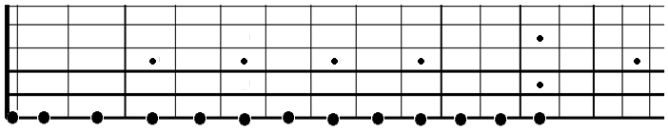
Applying the formula 2 2 1 2 2 2 1 to the diagram leaves us with this:
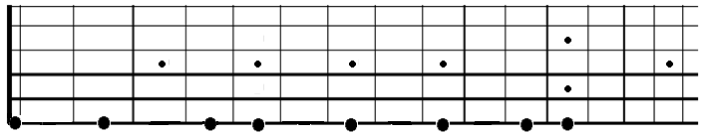
The notes are:
E F# G# A B C# D# E
The formula is the explanation for why the E Major Scale isn’t simply E, F, G, A, B, C, D, E as is sometimes wondered. The C Major Scale is the easiest to learn because it just so happens that when you apply the formula to a C root note, it won’t land on any of the untidy looking # or b. All of the other scales will contain at least one # or b. Don’t worry yet about whether to call a note # or b. Try to get used to calling them either one for now.
Here are all of the major scales:
C Major Scale: C D E F G A B
D Major Scale: D E F# G A B C#
E Major Scale: E F# G# A B C# D#
F Major Scale: F G A Bb C D E
G Major Scale: G A B C D E F#
A Major Scale: A B C# D E F# G#
B Major Scale: B C# D# E F# G# A#
C# Major Scale: C# D# F F# G# A# B#
Eb Major Scale: Eb F G Ab Bb C D
F# Major Scale: F# G# A# B C# D# F
Ab Major Scale: Ab Bb C Db Eb F G
Bb Major Scale: Bb C D Eb F G A

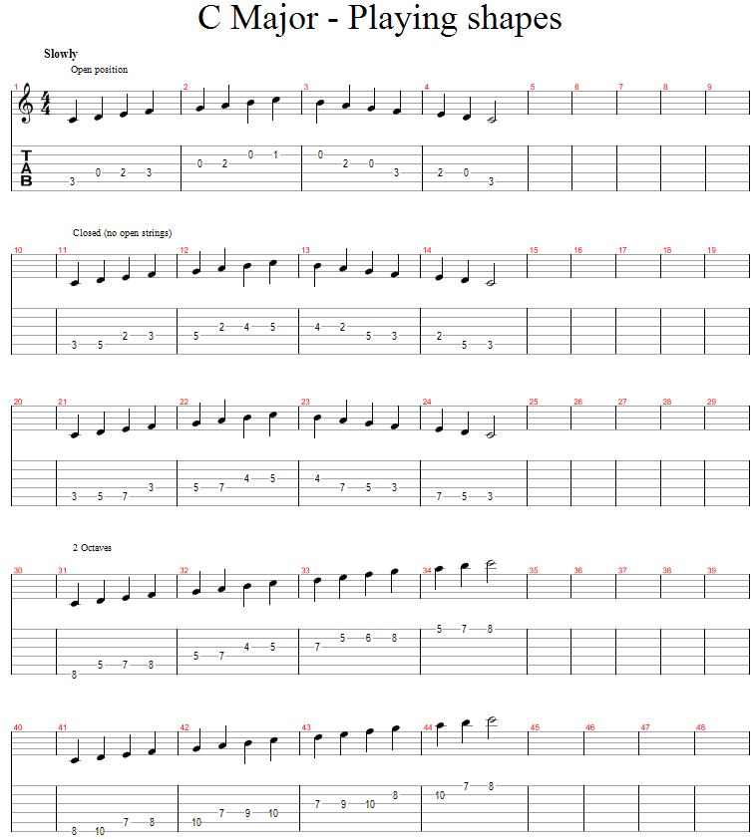
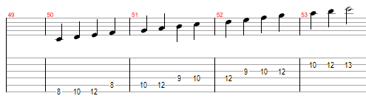
Harmonising the C Major Scale
Harmonising a scale is a great way of getting to understand how the notes in a scale can be stacked on top of one another to make chords. The process also develops general fretboard and chord knowledge which will in turn make you a better guitar player. Scales, then, can be played not only in lines of consecutive single notes but also in stacks of grouped notes that go together (chords).
The C Major chord is the starting point for us here:
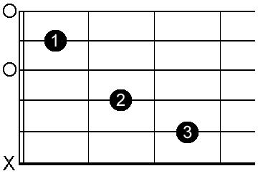
This chord spans 5 strings and from the root note on the 5th string the notes read:
C, E, G, C, E
As you can see, there is repetition of certain notes. The major chord, in fact, only needs to have 3 notes in it to give it the necessary characteristics to be known as, in this case, C Major. The notes are of course: C, E, G. You could play the chord diagram above but just miss out the top 2 strings. Looking at where these notes fit into the C Major scale now we can see that they…
C D E F G A B (C)
I II III IV V VI VII I
…are the 1st, 3rd and 5th notes in the scale (I, III and V). This type of chord is called a triad. Each note in the scale has its very own triad:
C E G - D F A - E G B - F A C - G B D - A C E - B D F
Make sure you understand that the root of the D triad is D and therefore its 3rd and 5th are F and A and not the same notes as in the C triad. If the root note shifts by one, the III and V shift along by one. See if you can compare the following triads of the C Major Scale to the full layout of the scale on a fretboard just below it and perhaps outline the triads with different coloured pencils to help spot them:
C D E F G A B C
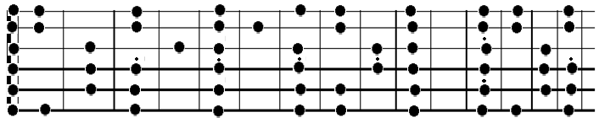
Listen to the sound of each triad and try to spot the differences between them. Specifically, see if you can spot which are major chords and which are minor and then spot which one sounds particularly different to the rest.
Remember the word intervals?
Looking at the C Major Scale in the last diagram we can now discover what this really means. Taking C again, on the 3rd fret/5th string, we now know that a 3rd above this is E. This interval is more accurately called a Major 3rd. The distance between the 2 notes is 4 half steps (or 4 semitones, or 2 tones). The distance to the 5th from E is only 3 frets this time. This distance is called a Minor 3rd. The total distance between the root note and the 5th is 7 frets.
So C triad = Root, Major 3rd, 5th
The next triad, starting on D is made up of D F A. Looking at D then (5th fret/5th string) and counting along the scale to a 3rd away (F on 8th fret) the distance travelled is less than before. We’ve only moved 3 frets (3 half steps or 3 semitones, or a tone and a half). Therefore, we call this interval a Minor 3rd. The interval between the 3rd and the 5th (F and A) is 4 frets. The distance between the root and the 5th is 7 frets.
Try to apply this to the next triads to see if you understand. The 5th is also known as the Perfect 5th because whether the 3rd is minor or major, the 5th lands the same interval from the root because of how the notes present themselves…
The one exception in this scale is in the B triad where we have a Minor 3rd (D) going to a 5th (F) which again is a distance of 3 half steps. The total distance between the root and the 5th now is only 6 frets. We will call this 5th a flattened 5th or b5.

To finish the harmonisation off, we need to add one more harmony: The 7th. For the C triad we need to add a B as you can see below
C D E F G A B (C)
I II III IV V VI VII I
The 7th of D is C
The 7th of E is D
The 7th of F is E …
As before, some are Major 7ths, others are Minor 7ths, one is a dominant 7th. The fully harmonised C major scale contains these chords. Study the statements in brackets:
Cmaj7 – C E G B (major 3rd + major 7th = maj7 chord)
Dmin7 – D F A C (minor 3rd + min 7th = min7 chord)
Emin7 – E G B D (minor 3rd + min 7th = min7 chord)
Fmaj7 – F A C E (major 3rd + major 7th = maj7 chord)
G7 – G B D F (major 3rd + min 7th = Dominant 7th chord or just ‘7’)
Amin7 – A C E G (minor 3rd + min 7th = min7 chord)
Bm7b5 – B D F A (minor 3rd + flattened 5th + min 7th = m7b5 chord)
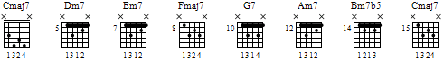
Or for more ‘open’ chords:
